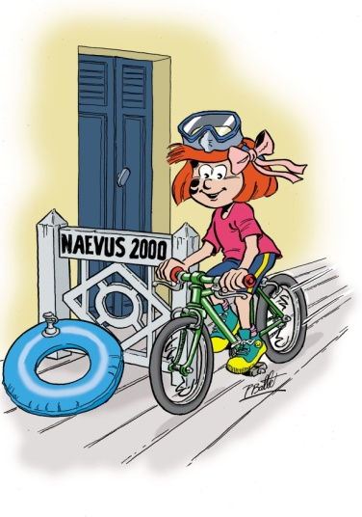

Madam, Sir,
Dear Friend,

Thanks to the partnership with Disney for several years, the invaluable help of Eric Pirès-Augère's (in charge of Disney’s Sponsorship Department), and the sale of our wonderful comic strip "Tout un Cirque" (Thanks to the Ballet’s family!), the association NAEVUS 2000 FRANCE EUROPE organizes an international family meeting at Disneyland Paris on October 8th and 9th, 2016.

However places are limited, this is the reason why we ask you to register as soon as possible by filling the registration form. All the associations of Global Naevus are invited on this event.
In order to make sure that everyone can fits in, it is necessary to take a commitment BEFORE END OF MARCH, 2016.

Here is some more information:
Accommodation will be in the hotel Sequoia Lodge (bedroom for 4 people, breakfast included, 2 double beds with possibility to add a Baby Cot for kids under 2-year-old).
The meeting as well as the official reception’s dinner will take place in the hotel New York, located 4 minutes’ walk to the Sequoia Lodge

On your arrival, volunteers of the association Naevus will welcome you at the hotel Sequoia Lodge, where they will hand you over your 2 Park tickets (studio and Disney) gracefully offered by the Disney’s Sponsorship department.
Bedrooms will be available from 15h, luggage can be stored at the hotel. It is thus necessary to lock your suitcase and to label it.

During the meeting, children will be able to have fun in the 2 parks, accompanied either by volunteers of Naevus 2000 or their relatives who would like to join the volunteers. 2 Park tickets (studio and Disney) are gracefully offered by the Disney’s Sponsorship department.
Agenda:
Saturday October 8th 2016
14 h à 17 h Exchanges, debates with the speakers at
Hotel New York
17 h Coffee break in Hotel New York
17h30 à 19h Debated to continue in Hotel New York
19h à 20h30 Free time
21h00 Gala evening in hotel New York

Sunday October 9th 2016
Free access to the 2 Parks (Studio & Disney), tickets kindly offered by Disney Sponsorship’s Department.

Hoping you’ll be joining us for this fabulous event, please do not hesitate to contact the members of the organizing team for any additional questions.

Laurence et Alain BAERT, | Hanane DOUIBI, | Gaëlle BONTEMPS, | Edwige DEGENEVE,
Président & Vice-Président  Naevus 2000 France - Europe. | Member of Naevus 2000 France Europe | Member of Naevus 2000 France Europe | Secretary of Naevus 2000 France Europe

